COMMANDS

less :The less command is particularly useful in viewing large files since it doesn’t load the complete file instead it loads the file part by part. By doing so the access time is much faster.
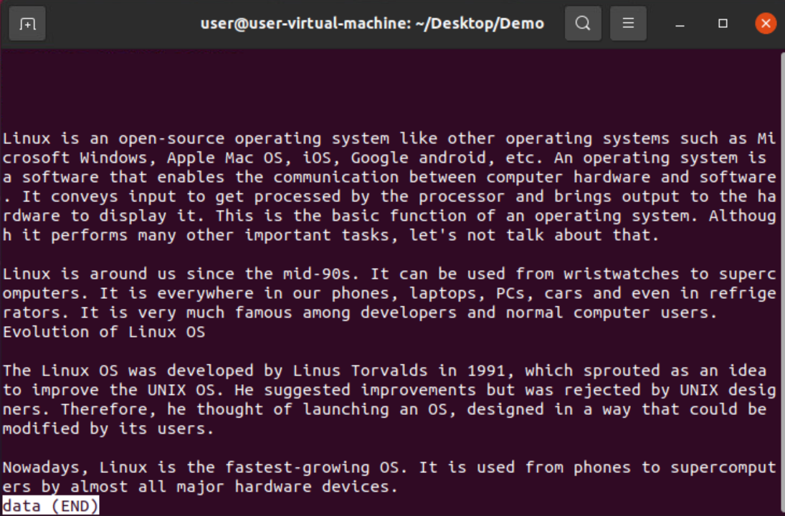

less -p data: it tells less to start at the first occurrence of pattern in the file.
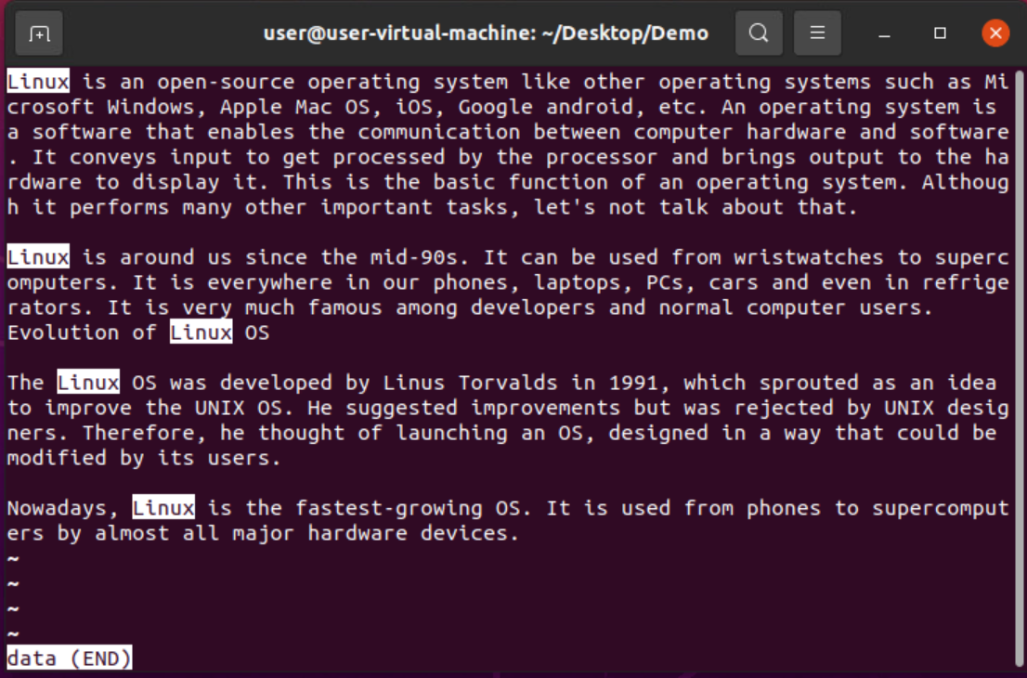

less -N data: It prints all the data with line numbers.
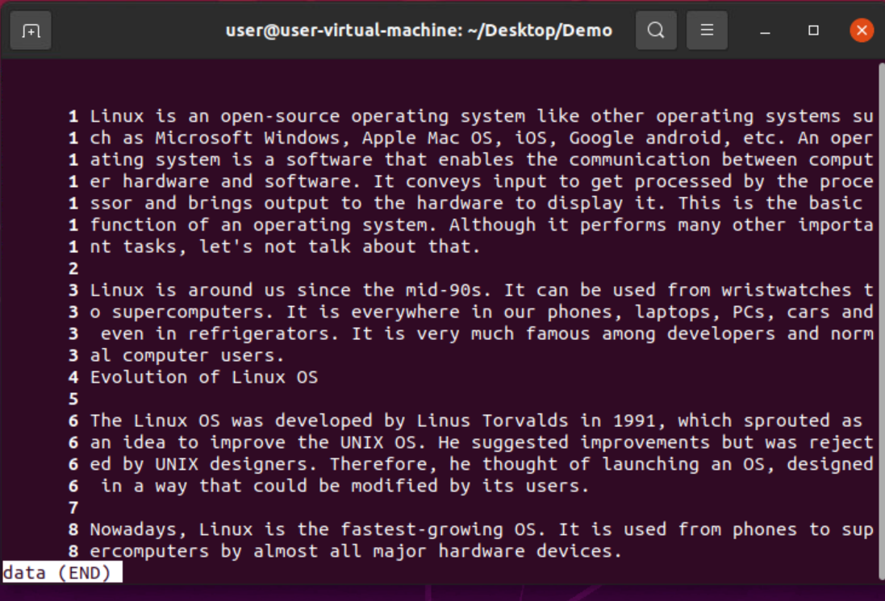
vim:
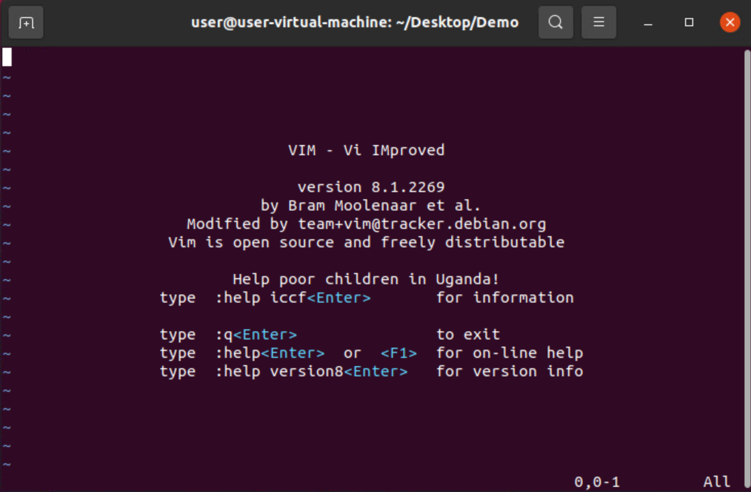

A (insert mode):

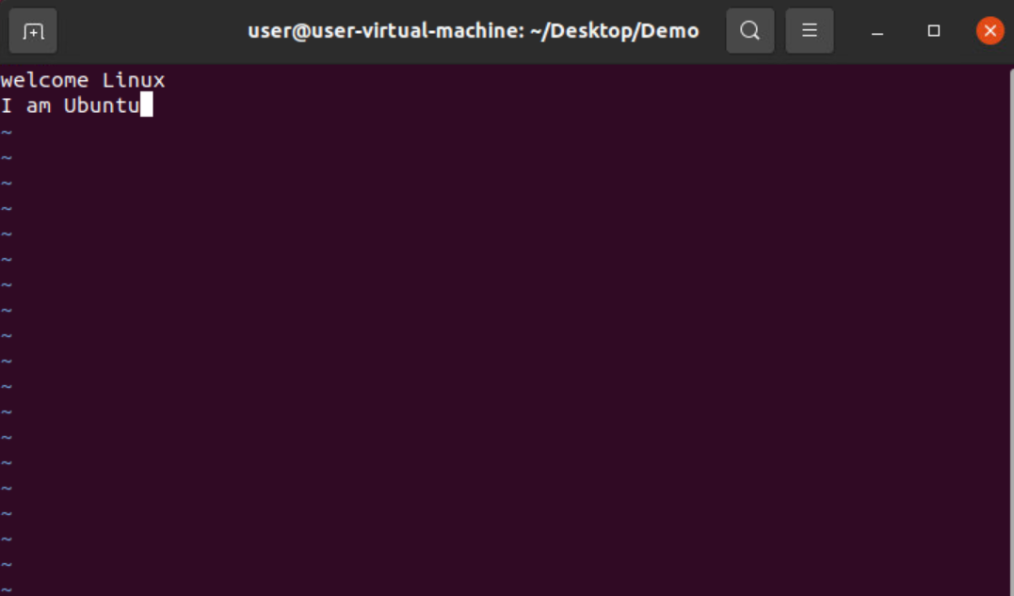

:w filename:

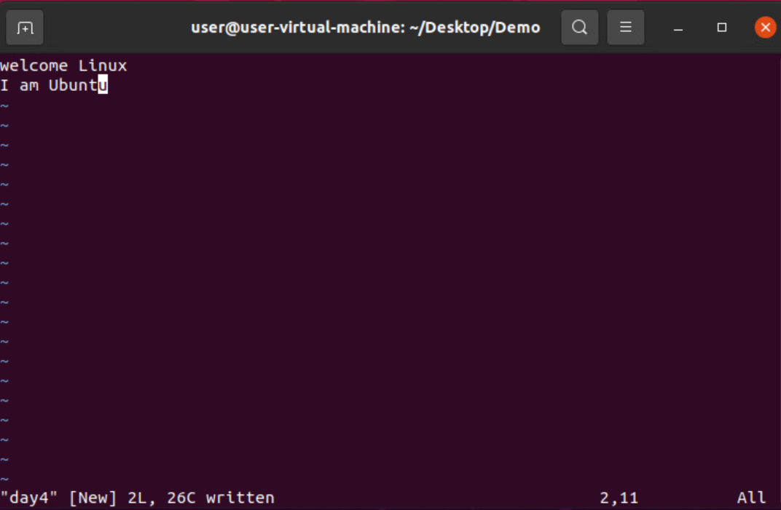

:d(delete):
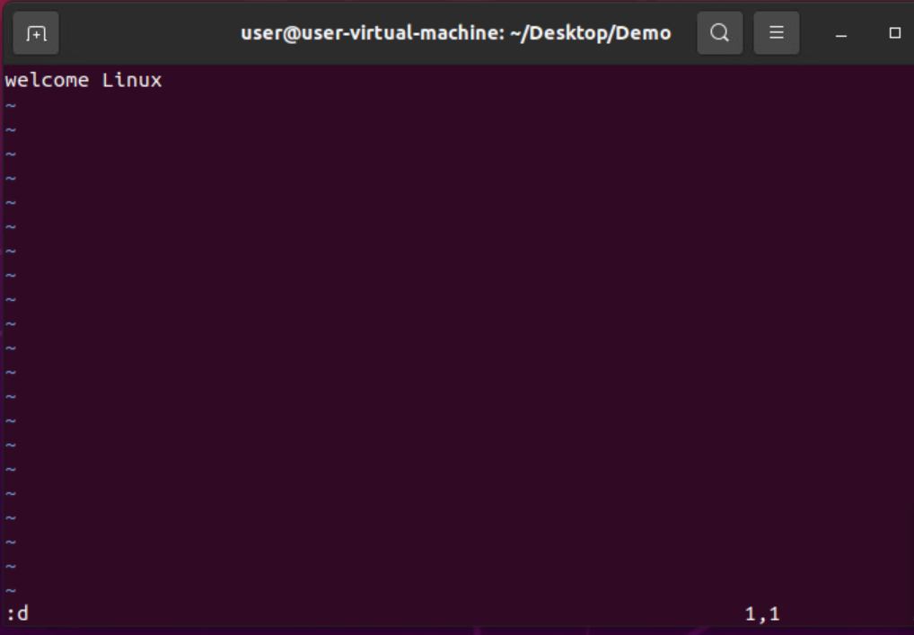
:u(undo):

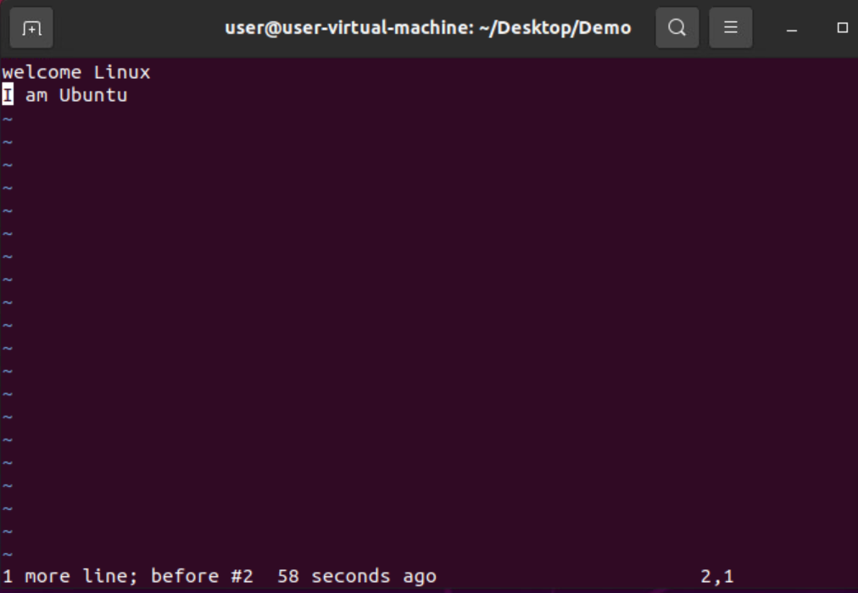
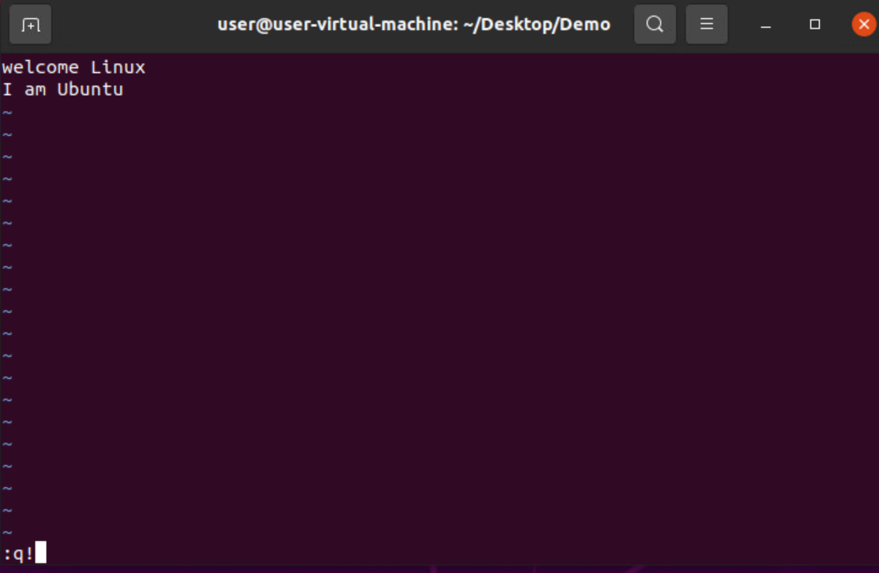
:q!(quit):

: r(read):
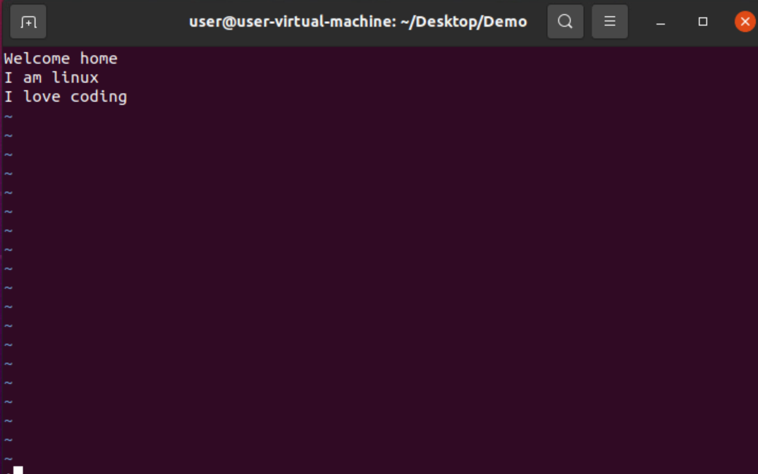
:w(write):
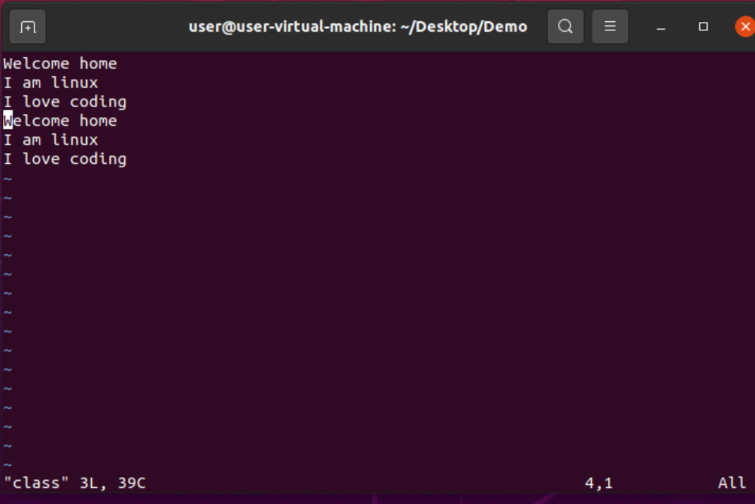

tail:It is the complementary of head command. The tail command, as the name implies, print the last N number of data of the given input. By default it prints the last 10 lines of the specified files. If more than one file name is provided then data from each file is precedes by its file name.
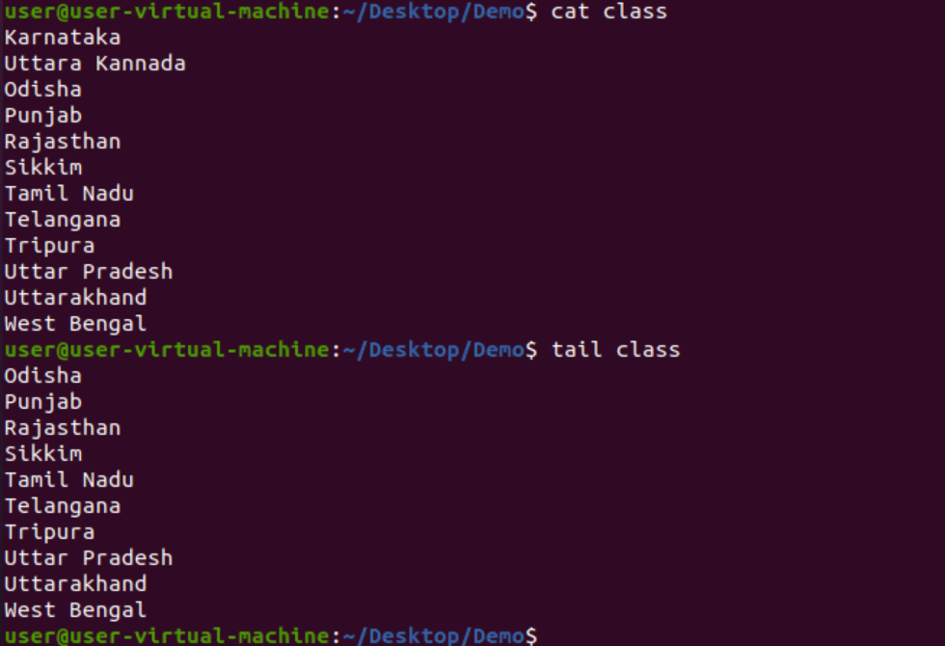
tail -n :
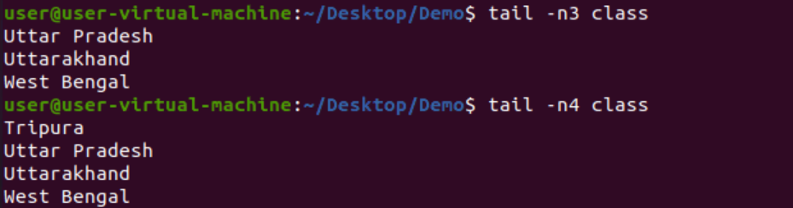

head:It is the complementary of tail command. The head command, as the name implies, print the top N number of data of the given input. By default, it prints the first 10 lines of the specified files. If more than one file name is provided then data from each file is preceded by its file name.
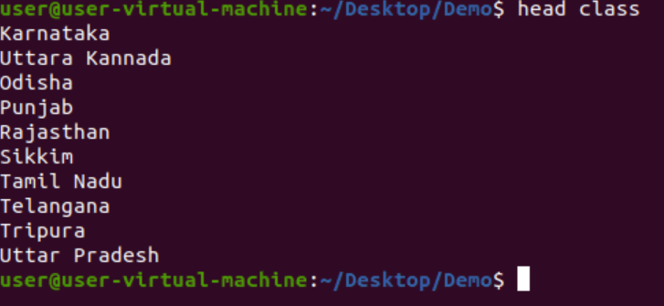
find:The find command in UNIX is a command line utility for walking a file hierarchy. It can be used to find files and directories and perform subsequent operations on them.

